Syntonic Learning
The idea of syntonic learning may at first be a difficult one to wrap your head around.
The idea was first introduced by Seymour Papert in Mindstorms and is based on Sigmund Freud’s idea of “ego syntonic”. This means that when a person is “ego syntonic” they are in harmony with their fundamental ideas and beliefs. For example, if you believe that it is wrong to tell a lie and you are in a position where you have opportunity to be honest, say a company undercharges you for an order. To be in harmony with your beliefs you would feel good to contact the company and tell then you owed them some money. Let’s say though you were having a bad day and you decided that day to not pay the extra that would require you to act against your beliefs and be “ego dystonic”.
The root of the word syntonic basically means “in harmony”. In electrical engineering if two circuits are resonating at the same frequency, they are described to be syntonic. The same might be true of two strings on a musical instrument.
Papert borrowed the idea expressed by Freud and applied it to the way that children learnt how to program. In developing Logo, a language to help children understand computer programming he devised a “turtle” which the children programmed, and the resulting code made the turtle move and draw patterns.
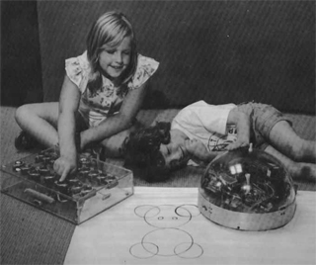
In his book Mindstorms he stated the following…
“The Turtle circle incident illustrates syntonic learning. This term is borrowed from clinical psychology and can be contrasted to the dissociated learning already discussed. Sometimes the term is used with qualifiers that refer to kinds of syntonicity. For example, the Turtle circle is body syntonic in that the circle is firmly related to children's sense and knowledge about their own bodies. Or it is ego syntonic in that it is coherent with children's sense of themselves as people with intentions, goals, desires, likes, and dislikes. A child who draws a Turtle circle wants to draw the circle; doing it produces pride and excitement.”
What Papert is describing here is the harmony between the child’s understanding of how to draw a circle, what a circle is and how to tell the turtle to do the same. In the case of body syntonicity the physical movements of both child and machine are in harmony.

Syntonicity and Constructivism
Perhaps one of the key links to make with the idea of syntonicity is the clear link between syntonic learning and constructivist theory.
Vygotsky proposed the idea of the Zone of Proximal Development.
“The zone of proximal development defines functions that have not matured yet, but are in a process of maturing, that will mature tomorrow, that are currently in an embryonic state; these functions could be called the buds of development, the flowers of development, rather than the fruits of development, that is, what is only just maturing” (Vygotsky, 1978).
Vygotsky sees the zone of proximal development as the area where guidance and instruction should be given, facilitating the development of further higher mental functions.
And here lies the point of syntonicity.
We have already pointed out that computers are not people and people are not computers. This creates the possibility of there being a huge gap between how the human player in the system understand what the computer is up to. We have established that inappropriate mental models applied to a computer system can mean that we as user/programmers can fail to predict the outcome of the computer and its code. If this happens then it is likely that the person attempting to work with the computer will disengage and give up. This is also true of the zone of proximal development. There is a sweet spot in the learning process. If we create a learning experience that is too hard to work with, too hard to understand then the learner is likely to give up in frustration. Inversely if the task it too easy or too boring then the learner is likely to get bored and give up.
If we get the level of the task and the design of the task right it will become a beneficial learning experience.
Considering syntonicity is one way of approaching system / instructional design such that the user / learner engages with the content in a more meaningful fashion.
Syntonicity may be seen as a kind of metaphor. For example, Scratch uses the metaphor of blocks which are rather like jigsaw pieces which are something a child is able to relate to.
This means that this code…
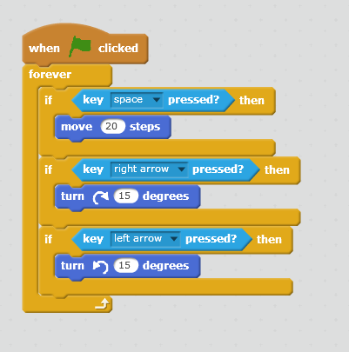
Is much easier to understand than this code…
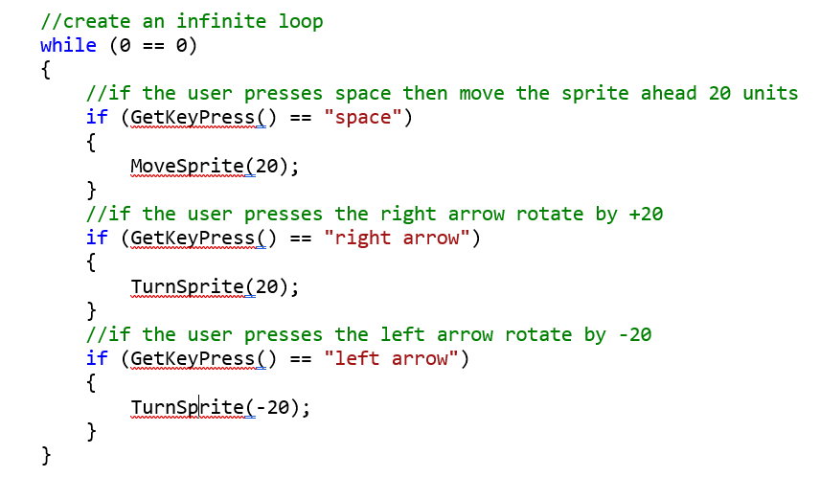
Syntonic learning runs a bit deeper than a metaphor in that it relates to some personal aspect of the learner. It is this we are trying to capture in our instructional design.

Take a Break
Take a look at the blog Post by Uttam (2016) linked on the module web site.
Consider the following two questions…
- What other types of syntonicity can you identify?
- According to the blog author, how does Scratch extend or challenge the ideas of syntonicity that were associated by the older educational programming language Logo?
Papert identifies three types of syntonicity, body syntonic, ego syntonic, and culturally syntonic.
Body syntonic may be the best to consider for young children as the movement of their body is something they can relate to at an earlier age, ego and culture may come a bit later.
In the case of ego syntonicity it is the idea that the child is engaging in a task in a game that means something to them at a personal level, say collecting food. In the case of cultural syntonicity the child would need to engage in a task that makes sense to them as part of their cultural context.
Scratch can be very good at creating engagement with the last two but possibly not so good at the first one, body syntonicity as movement is happing only notionally on the screen.
Or perhaps it doesn’t matter…
Here are some quotes from case studies of Year 6 pupils using Scratch in 3 primary schools by Julia Briggs, Primary Education Technology Advisor, Somerset County Council. (Unfortunately, the link is now gone)
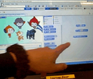
“A pair of girls discovered ways to move and turn their character around the screen. Their enjoyment was clear and also their willingness to ‘have a go’ to see what might happen.”
“A pair of boys became fascinated by the movements they caused, ‘He’s circling, he’s going sideways because he’s a crab.’”
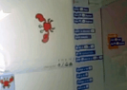
“Papert’s (1984) description of the turtle in logo programming, as being body syntonic, was echoed by the children who explored the use of programming blocks to create movements for sprites.”
“[… The] pair of girls giggled as their actions caused the character to turn or move off the stage. [The] pair of boys was proud of their crab which moved sideways round a circle.”
In these examples we can see how the activity and the child are “in harmony” with the activity and the resulting sense of fun and satisfaction.

So What?
Some questions to ask about Zombie Island.
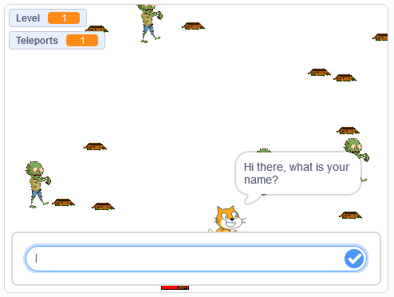
The target group and age range are never specified for this sample program, but at what point does the program as it stands start to become inappropriate? At what age do Zombies have some sort of resonance with children?
Currently the language of the Scratch character runs something like this…

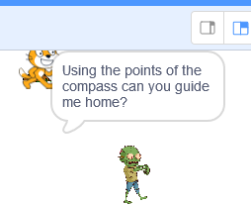
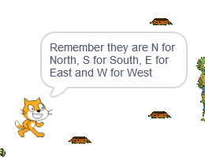
Note especially the final step…
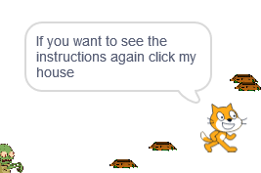

What if we change the language of the character like so?
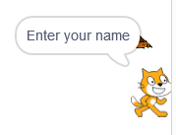

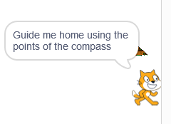
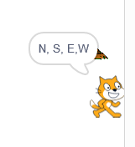
Finally, what if we changed the zombie graphic to this?


Further Reading
Vygotsky L. S. (1978) Mind and Society, Cambridge MA: Harvard University Press.

